What is the average percentage of people experiencing severe loneliness in the PC4 areas?

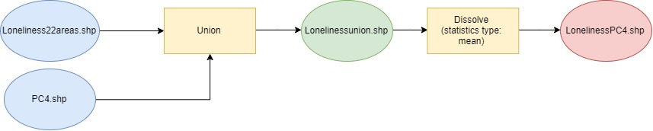

What is the average urban heat island effect per PC4 area?

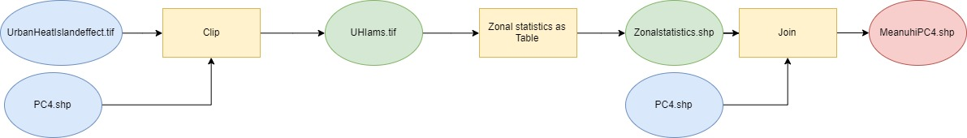

 What is the average income per PC4 area?

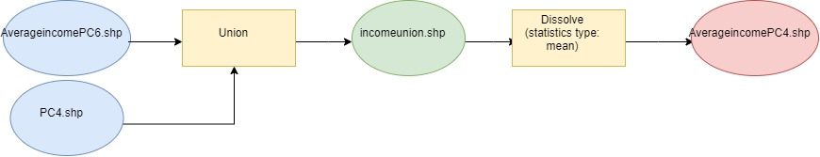

g

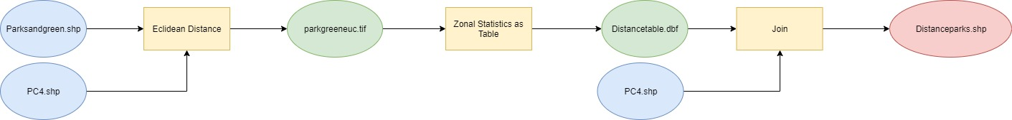

What is the average percentage of water area in the PC4 areas?

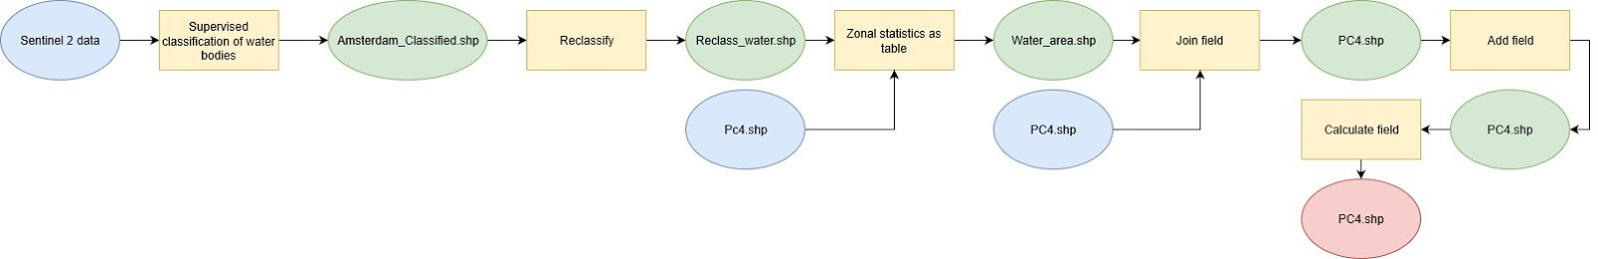

What is the average tree density per PC4 area?

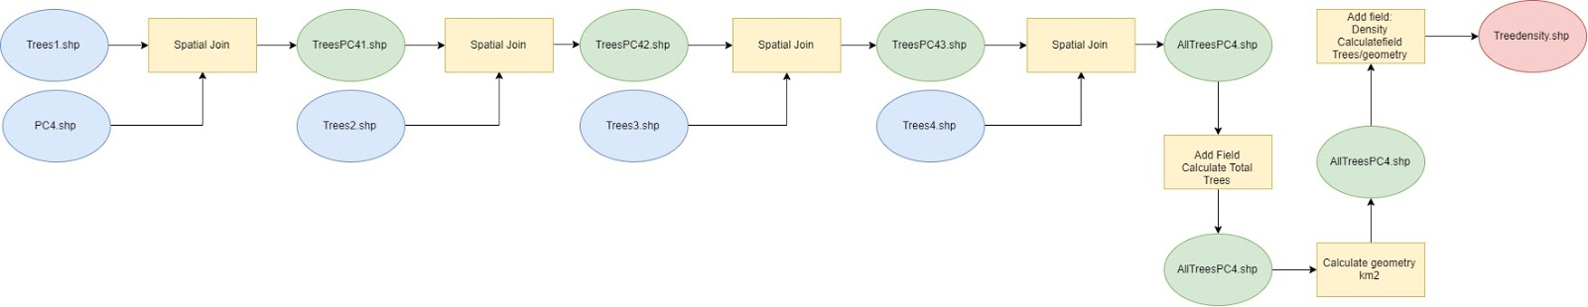

f

What is the average enerygy label per PC4 area?

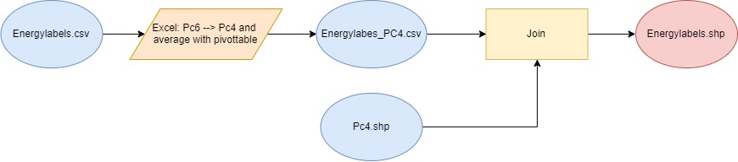

What is the average year of construction per PC4 area?

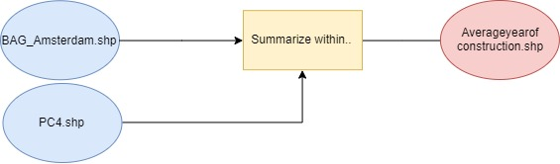

What is the average green roof density per PC4 area?

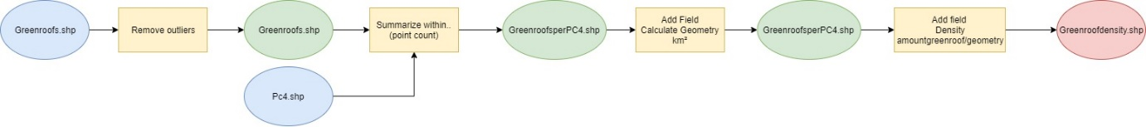

What is the average wall plant density per PC4 area?

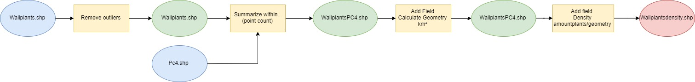

What is the average distance to hospitals per PC4 area?

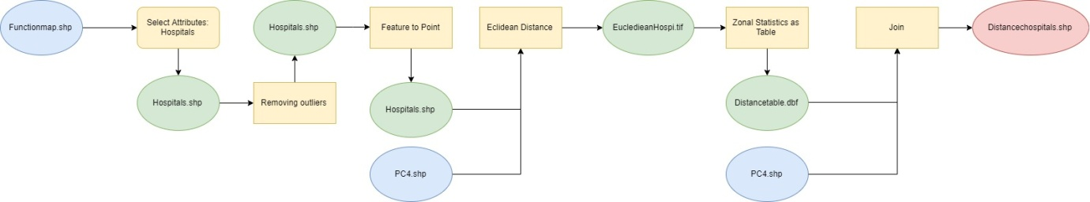

What is the average distance to residental care complexes per PC4 area?

